Wireshark Lab 3: TCP

Group Details:
Ho Seok Lee (1004112177)
Neehar Kantimahanti (1003872286)

Mark:

 | Question | Answer
1 | What is the IP address and TCP port number used by your client computer (source) that is transferring the file to gaia.cs.umass.edu? | The IP address is 192.168.1.102, and the TCP port number is 1161.
Annotated Screenshots  (if needed) | 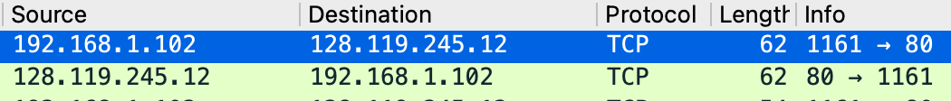
2 | What is the IP address of gaia.cs.umass.edu? On what port number is it sending  and receiving TCP segments for this connection? | The IP address of gaia.cs.umass.edu is 128.119.245.12, and the TCP port number is 80.
Annotated Screenshots  (if needed) | 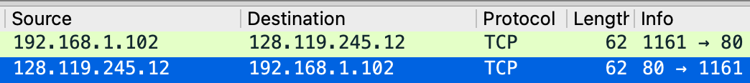
Question 3 omitted
4 | What is the sequence number of the TCP SYN segment that is used to initiate the TCP connection between the client computer and gaia.cs.umass.edu? What is it  in the segment that identifies the segment as a SYN segment? | The sequence number of the TCP SYN segment is 232129012.  The SYN flag is set to 1.
Annotated Screenshots  (if needed) | 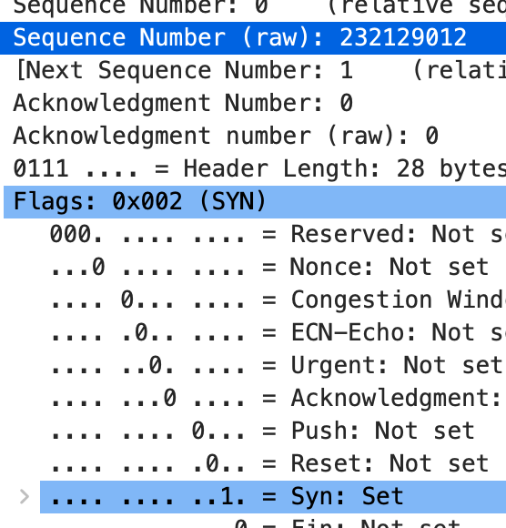
5 | What is the sequence number of the SYNACK segment sent by gaia.cs.umass.edu to the client computer in reply to the SYN? What is the value of the ACKnowledgement field in the SYNACK segment? How did gaia.cs.umass.edu determine that value? What is it in the segment that identifies the segment as a  SYNACK segment? | The sequence number of the SYNACK segment is 883061785.  The value of the ACK field is 232129013. This is set by adding 1 to the sequence number of the SYN packet.  Both the SYN and ACK flags are set to 1.
Annotated Screenshots  (if needed) | 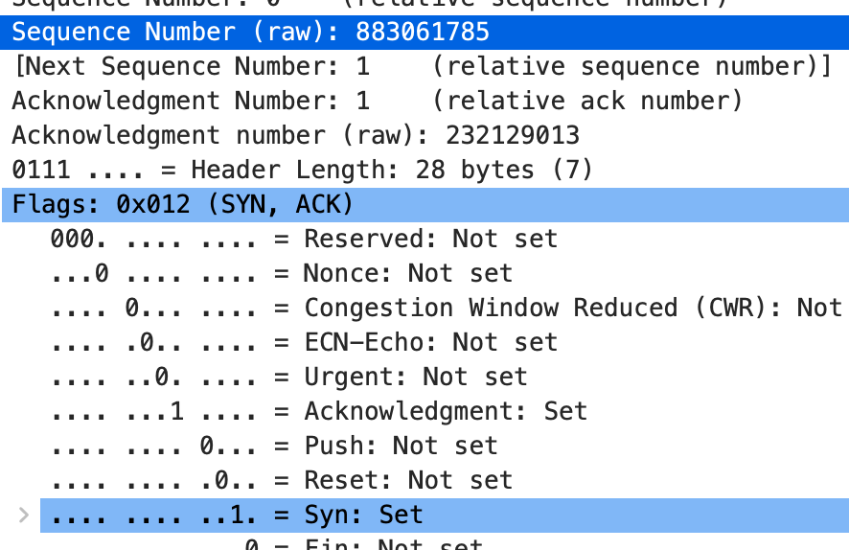
6 | What is the sequence number of the TCP segment containing the HTTP POST command? | The sequence number is 232129013.
Annotated Screenshots  (if needed) | 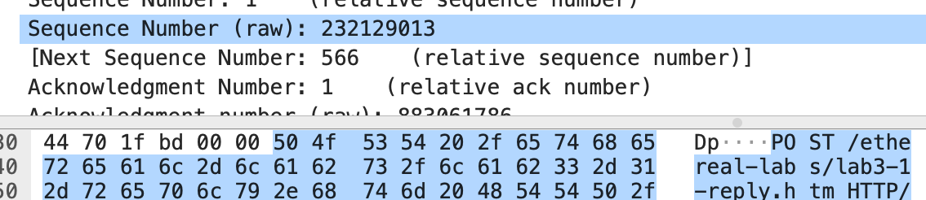
7 | Consider the TCP segment containing the HTTP POST as the first segment in the TCP connection. What are the sequence numbers of the first six segments in the TCP connection (including the segment containing the HTTP POST)? At what time was each segment sent? When was the ACK for each segment received?  Given the difference between when each TCP segment was sent, and when its acknowledgement was received, what is the RTT value for each of the six segments? What is the EstimatedRTT value after the  receipt of each ACK? | The sequence numbers and the time that they were sent are  - 232129013 (0.026477),  - 232129578 (0.041737),  - 232131038 (0.054026),  - 232132498 (0.054690),  - 232133958 (0.077405), and  - 232135418 (0.078157).  The ACK for each segment was received at  - 0.053937,  - 0.053937 (cumulative),  - 0.077294,  - 0.124085,  - 0.169118, and  - 0.217299.  The RTT value and estimated RTT value (assuming alpha as 0.125) for each segment is  - 0.02746 (0.02746),  - 0.0122 (0.025552),  - 0.023268 (0.025267),  - 0.069395 (0.030783),  - 0.091713 (0.038399), and  - 0.139142 (0.050992).
Annotated Screenshots  (if needed) | 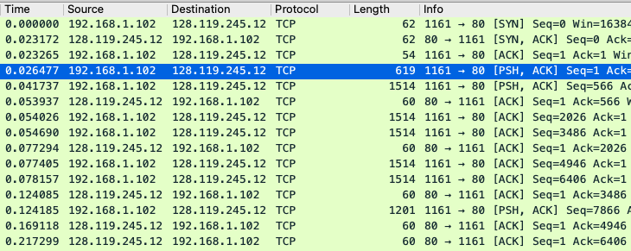
8 | What is the length of each of the first six TCP segments? | The lengths of the first six TCP segments are  - 565,  - 1460,  - 1460,  - 1460,  - 1460, and  - 1460.
Annotated Screenshots
(if needed)
9 | What is the minimum amount of available buffer space advertised at the received  for the entire trace? Does the lack of receiver buffer space ever throttle the  sender? | The minimum amount of available buffer space is 6780 bytes.  The lack of receiver buffer space never throttles the sender.
Annotated Screenshots  (if needed) | 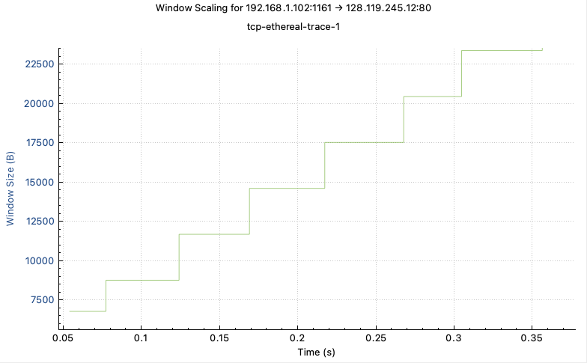
10 | Are there any retransmitted segments in the trace file? What did you check for (in the trace) in order to answer this question? | None of the segments are being retransmitted.  If two segments have the same sequence number, they are retransmitted segments.
Annotated Screenshots
(if needed)
11 | How much data does the receiver typically acknowledge in an ACK? Can you identify cases where the receiver is ACKing every other received segment | The receiver typically acknowledges 1460 bytes of data, which is the size of one segment.  If the receiver receives in-order segments with an expected sequence number, and all segments up to that point has been acknowledged, the TCP will send an ACK for every other packet. In the case of an additional in-order segment waiting for acknowledgement, TCP will immediately send a single cumulative ACK for both segments.
Annotated Screenshots  (if needed) | 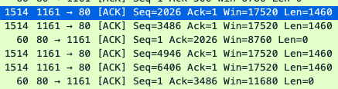
12 | What is the throughput (bytes transferred per unit time) for the TCP connection?  Explain how you calculated this value. | The throughput of the TCP connection is 240, 711 bits per second.  This can be calculated by dividing the relative ACK number of the last packet 159389 by the timestamp 5.297257.
Annotated Screenshots  (if needed) | 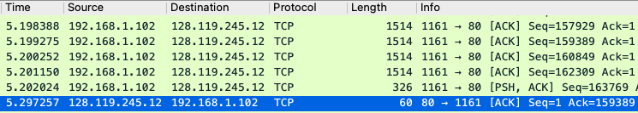
13 | Use the Time-Sequence-Graph (Stevens) plotting tool to view the sequence number versus time plot of segments being sent from the client to the gaia.cs.umass.edu server. Can you identify where TCP’s slowstart phase begins and ends, and where congestion avoidance takes over? Comment on ways in which the measured data differs from the idealized behavior of TCP that we’ve studied in the text.  Tip: if your time sequence doesn’t look like the one in the handout, try pressing the Switch Direction button. | In the first few milliseconds, around packet 13, the TCP transitions from slowstart phase into congestion avoidance.  Once congestion avoidance begins, the TCP begins sending 6 packets at a time consistently until the end of the transfer. The text that we’ve studied indicates that the rate of transmission of packets should increase linearly, but this TCP does not. This rate limit might be enforced by the HTTP server.
Annotated Screenshots  (if needed) | 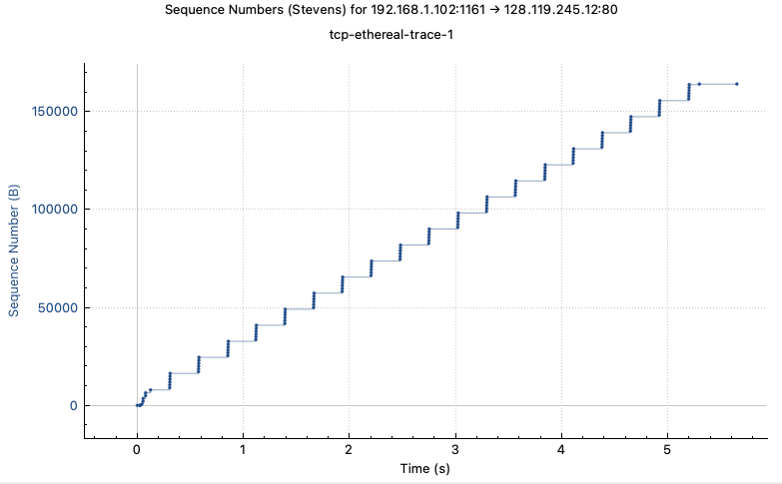
Question 14 omitted

